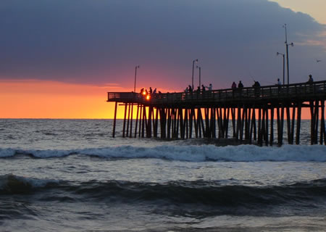

irginia Beach is where I grew up

ll my friends and family mean the world to me.

est oldest sister is a title I hope I am known as.

ven though I live at the beach, I can’t surf.

lways have lived in a family of all girls.

hatty Kathy could be a nickname for me.

ome is wherever my friends and family are.

**V**

**A**

**.**

**B**

**E**

**A**

**C**

**H**